Introduction to version control Assignment
Date: 5th Feb 2019

1: Git Setup https://confluence.atlassian/bitbucket/set-up-git-744723531.html.

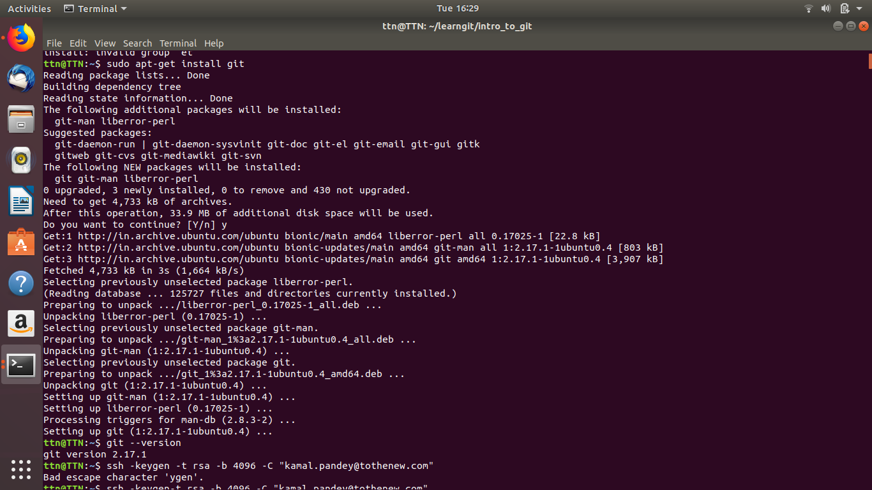

2: Initialize a Git Repository.
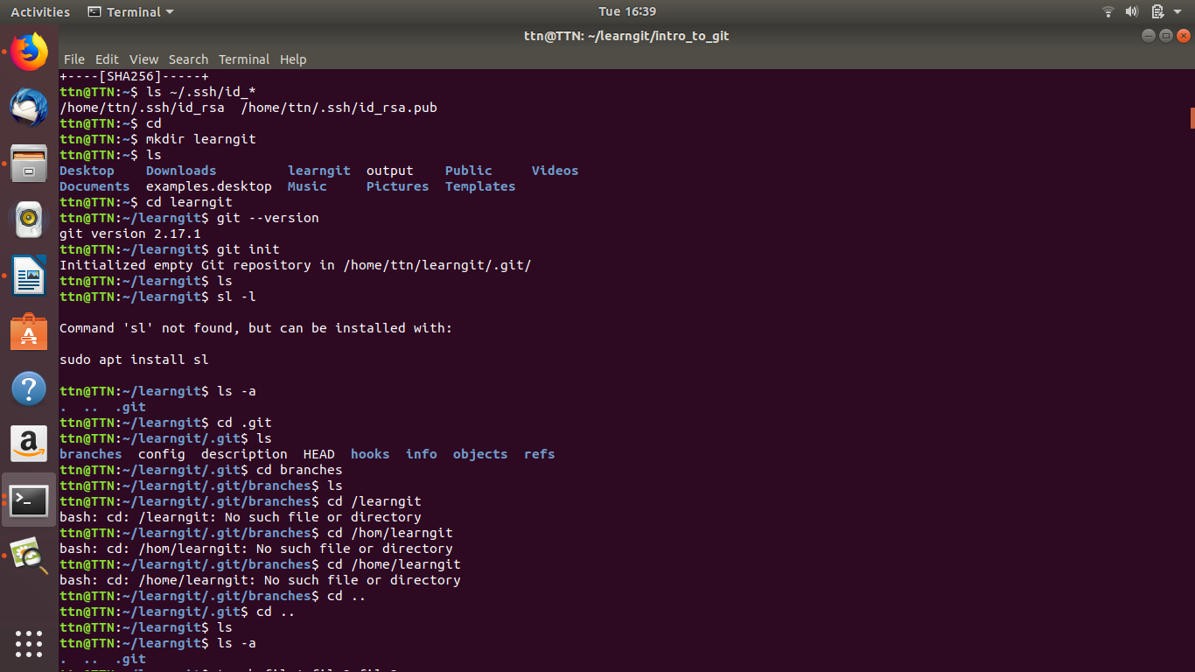

3: Add files to the repository.

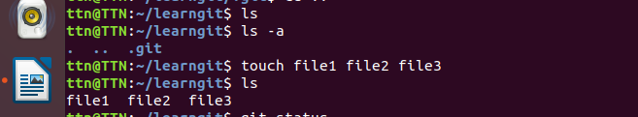

4: Unstage 1 file.

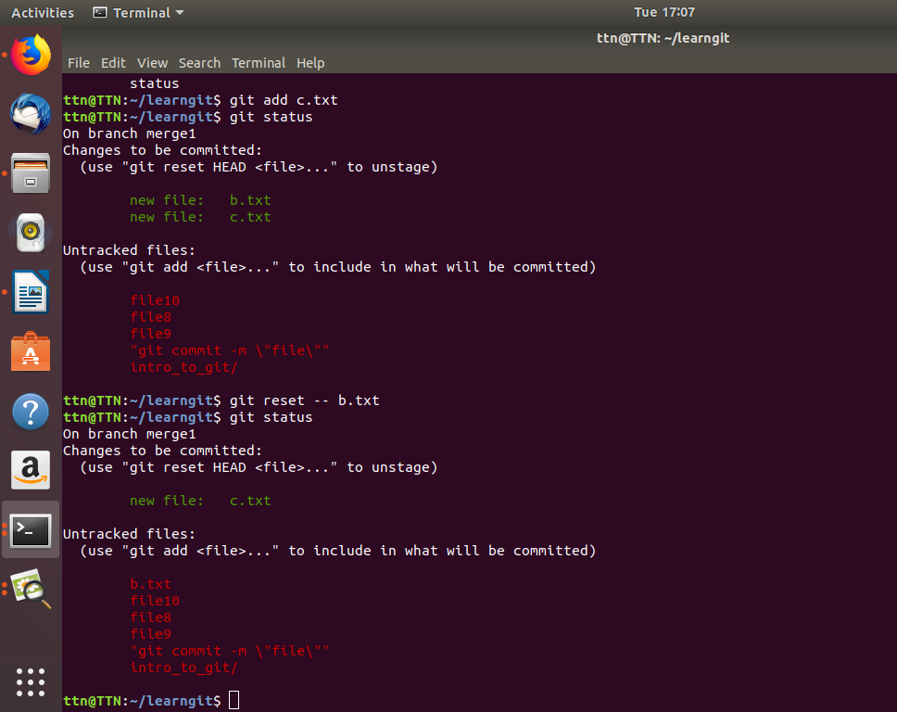

5: Commit the file.

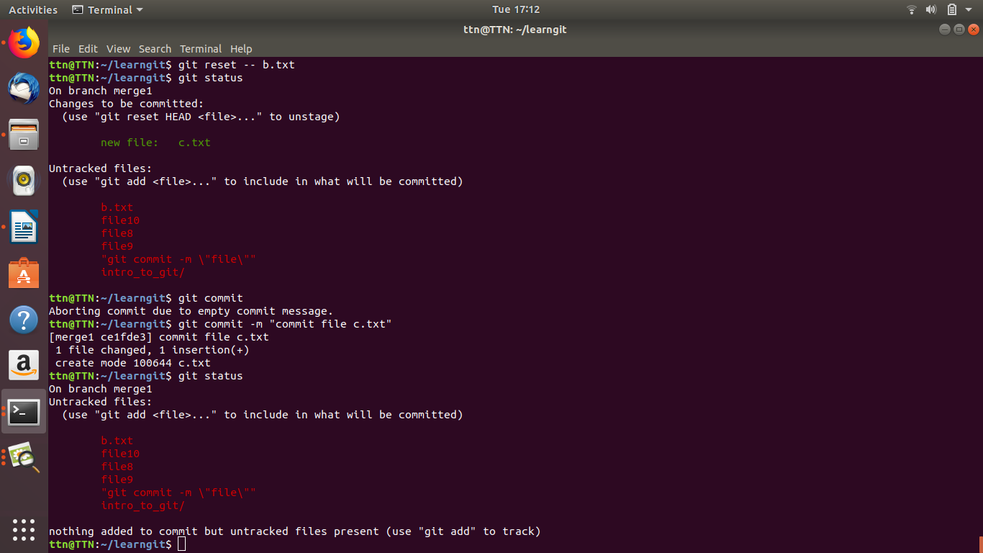

6: Add a remote.
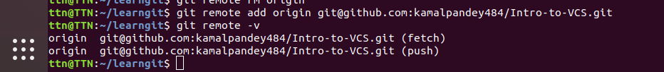

7: Undo changes to a particular file.
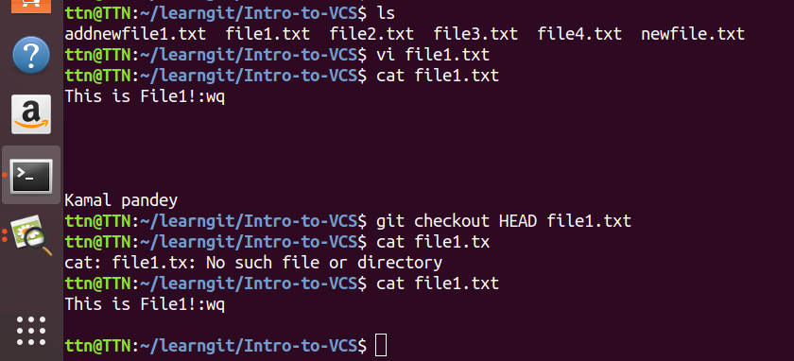

8: Push changes to Github.
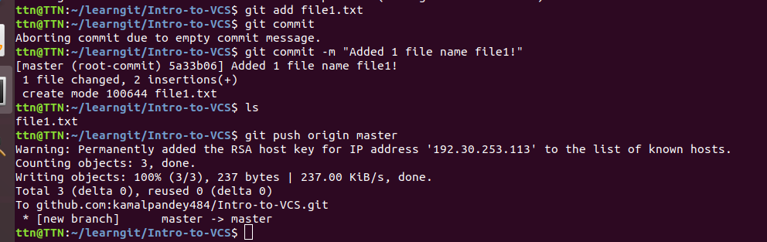

9: Clone the repository.

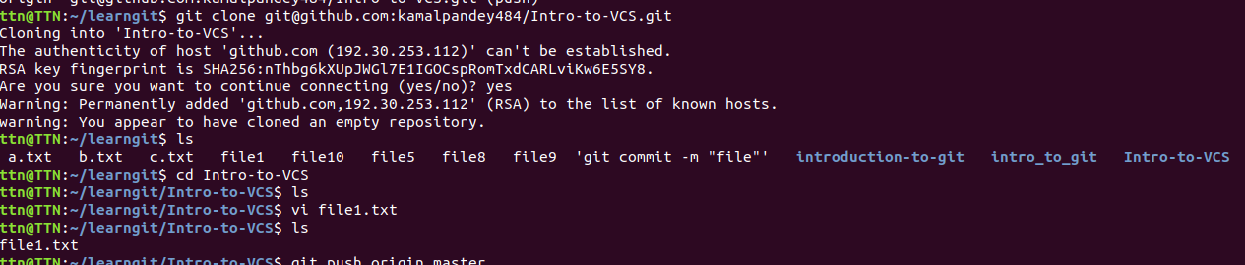

10: Add changes to one of the copies and pull the changes in the other.

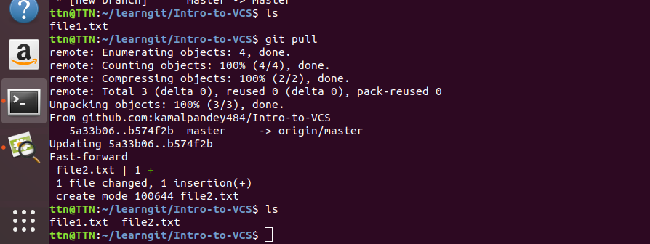

11: Check differences between a file and its staged version.

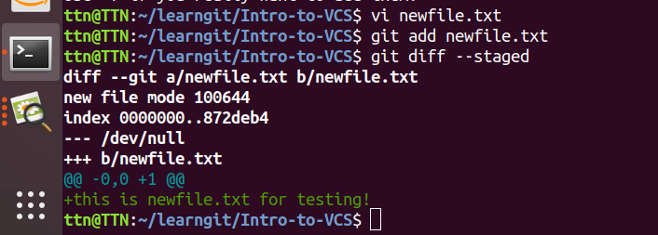

12: Ignore a few files to be checked in.

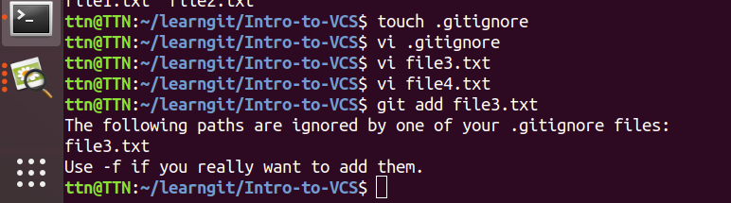

13: Create a new branch.

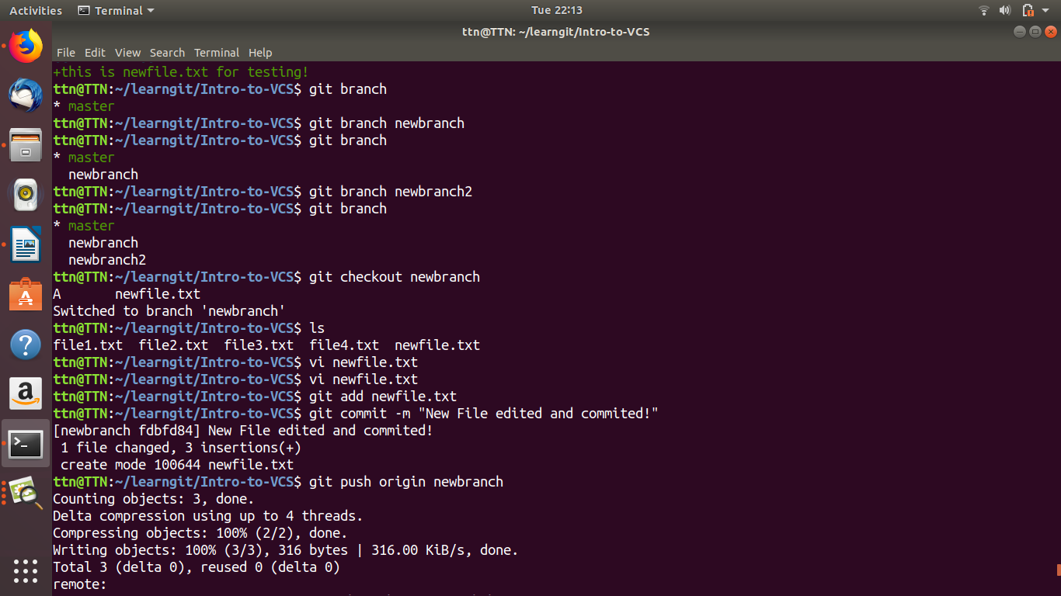

14: Diverge them with commits.

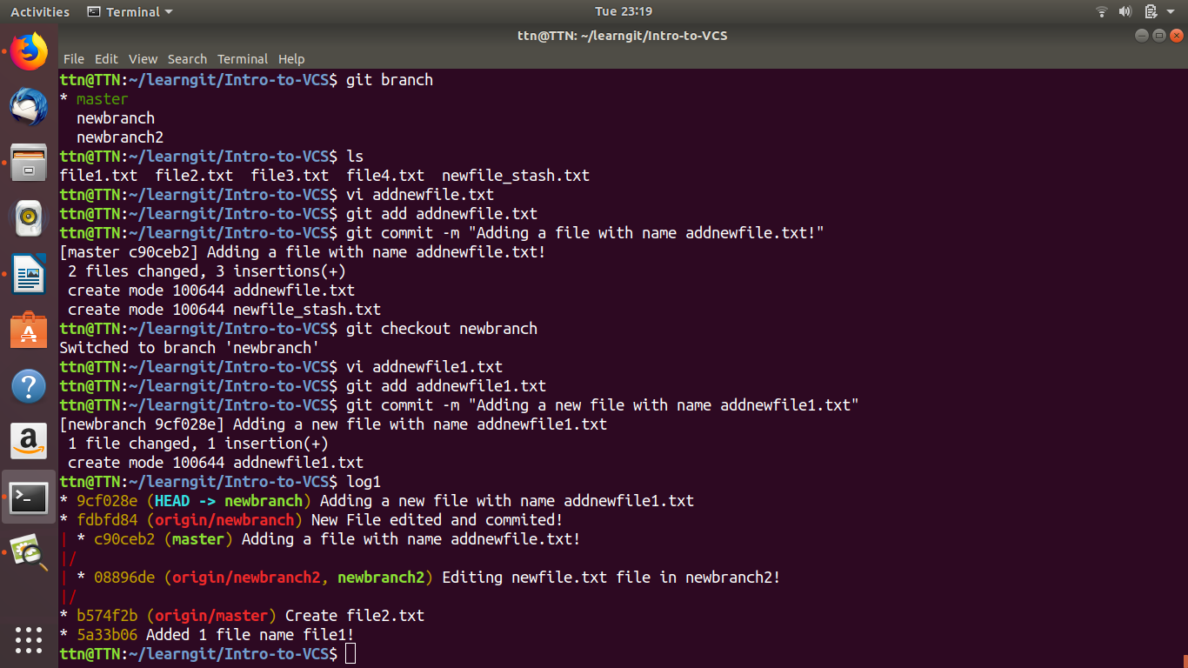

15: Edit the same file at the same line on both branches and commit.

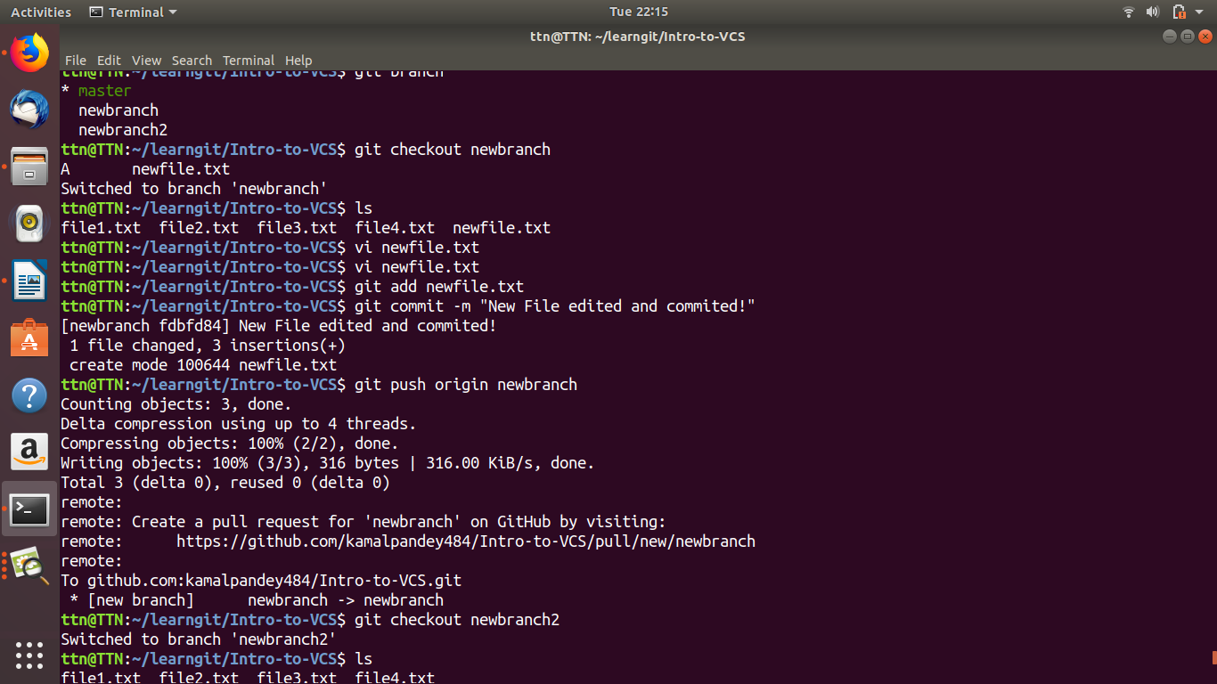
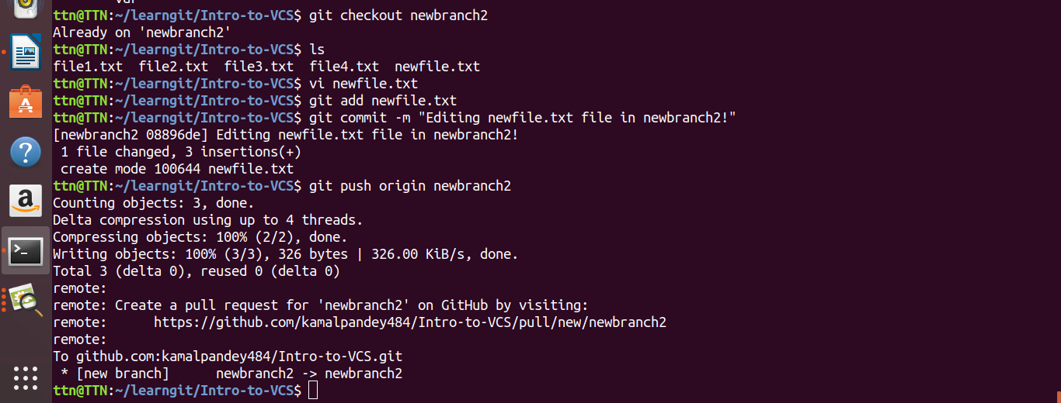

16: Try merging and resolve merge conflicts.

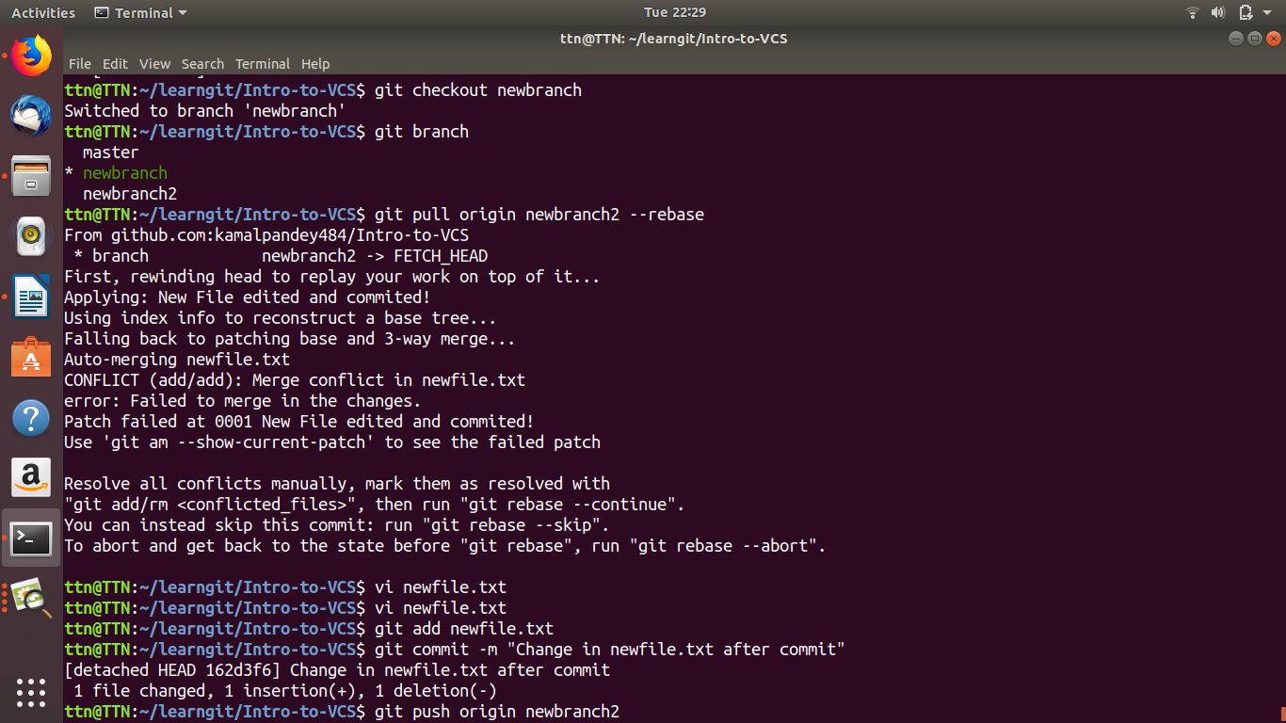

17: Stash the changes and pop them.

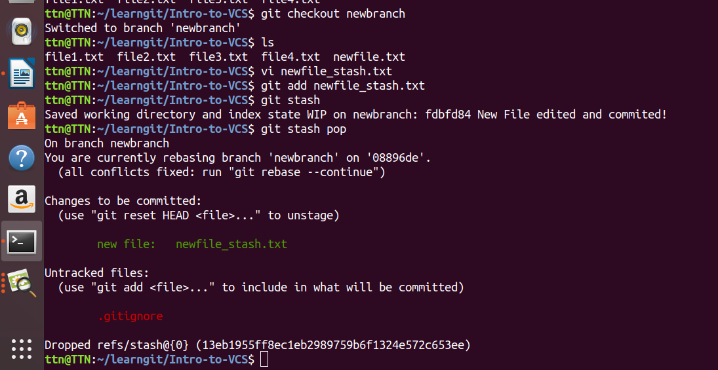

18: Add the following code to your .bashrc file :
color_prompt="yes"
parse_git_branch() {
git branch 2> /dev/null | sed -e '/^[^*]/d' -e 's/* \(.*\)/(\1)/'
}
if [ "$color_prompt" = yes ]; then
PS1='\u@\h\[\033[00m\]:\[\033[
else
PS1='\u@\h:\W $(parse_git_branch)\$ '
fi
unset color_prompt force_color_prompt

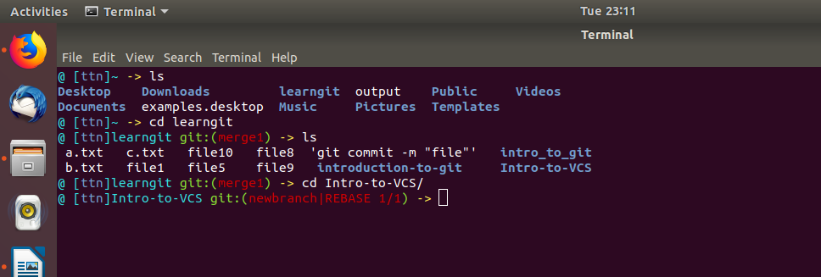

Problems:
1: Diverge with conflicts
2: Merge conflicts.

